5.4.1( 3)-Alumni Contribution – Non Financial- Guest Talk and Training

1. Mr. Darshan ( 2014)– Senior Executive – Birla super White Cement , Bangalore
- Visited the department on 3/01/2022 and interacted with the MBA second year Marketing students
- Guided students to develop skills required by marketing students.

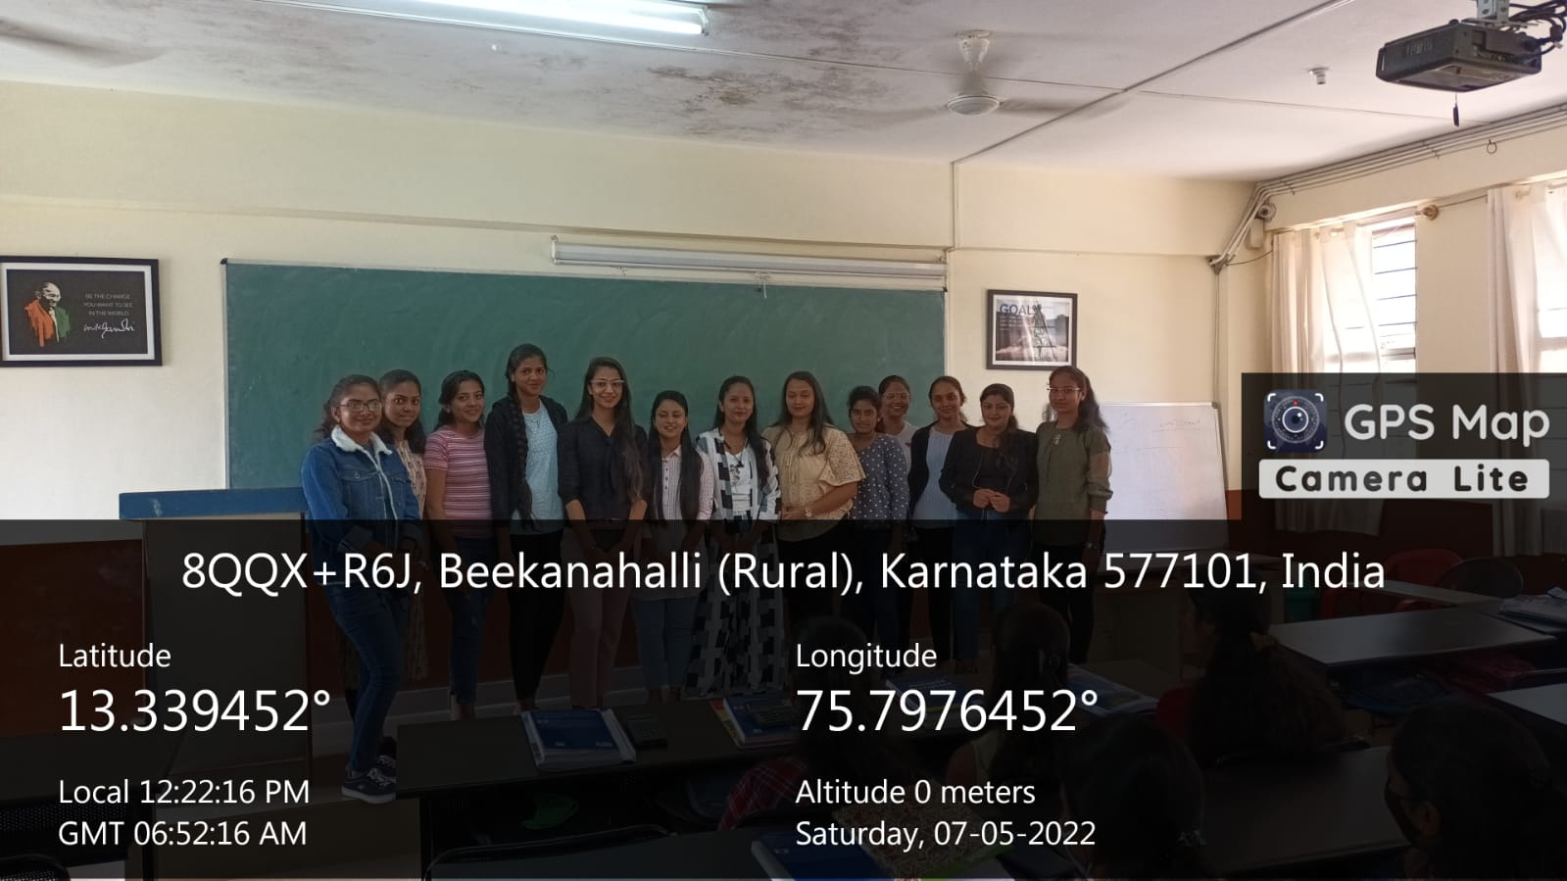

- 2. . Ms. Sunaina Sadaf ( 2021 )– Talent Acquisition Executive – Infosys , Bengaluru
- Visited the department on 3/03/2022 and interacted with the I year Marketing students
- Guided students to develop skills required by the students in placing corporate .

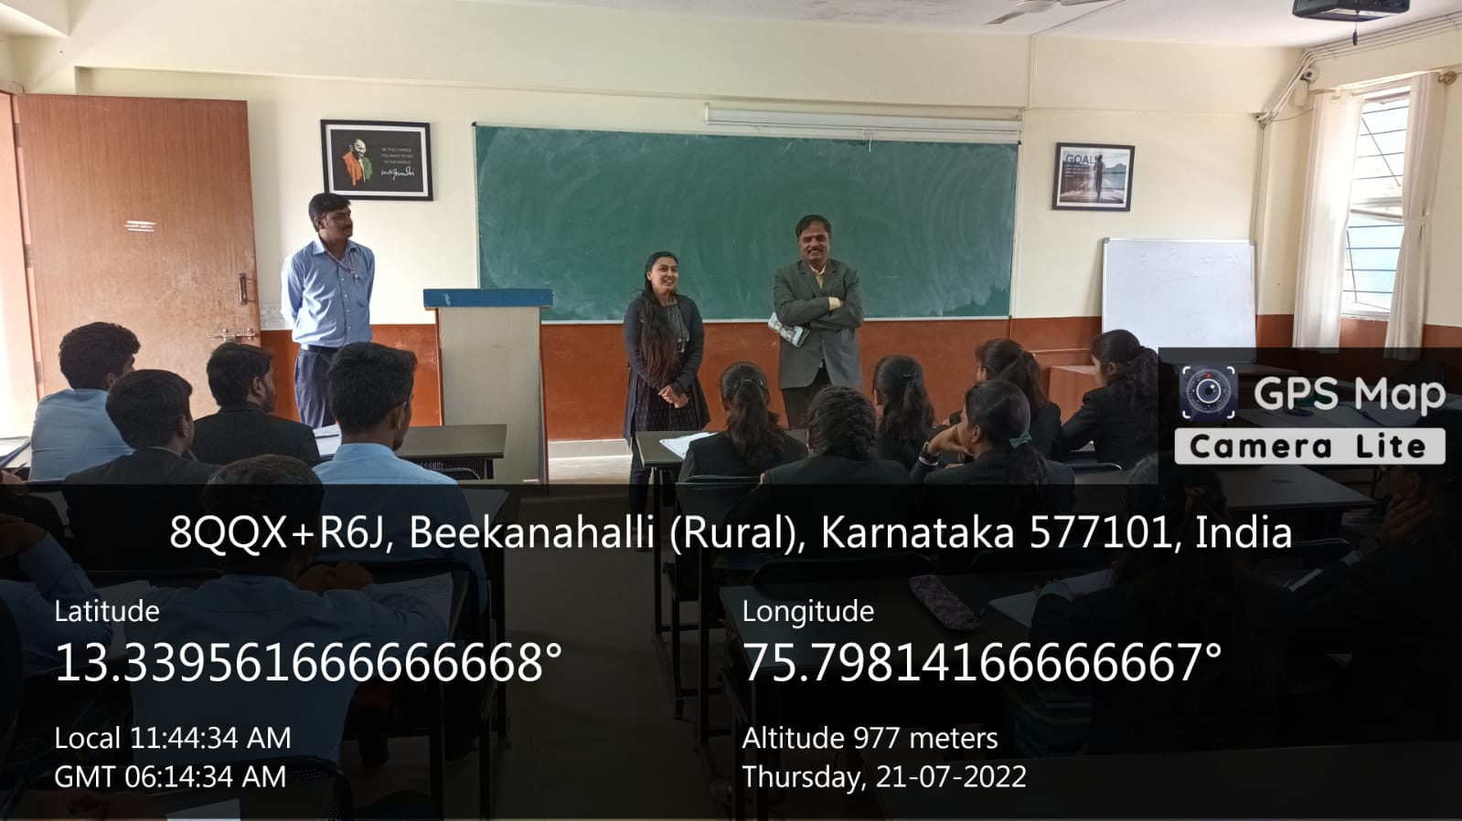
- 3.Ms. Ausha Cyril ( 2019 )– Senior Associate -Exist team – Amazon , Bangalore,
- Visited the department on 21/07/2022 and interacted with the II year students
- She explained about importance of effective resume and how to use social media for getting job, she also explained importance of link din for know the job vacancy

